Navigation and
Ship’s log reader

14th edition
October 9 – 13, 2019

TABLE OF CONTENT

- Introduction p. 3
- The earth p. 4
A layout of the earth p. 4
Latitude and longitude p. 4
- The sea chart p. 6
Determining latitude and longitude of a position on the chart p. 6
Plotting a position on the chart of a given latitude and longitude p. 6
Determining a course between two positions p. 6
Plotting a course from a given position p. 7
Measuring distances p. 7
- Drift, current and course calculations p. 9
Drift p. 9
Current p. 9
Course p. 10
- Log entry / filling out the log p. 12
- Units, terms and abbreviations p. 13

INTRODUCTION

In front of you is the navigational reader that is meant as background information to be used while filling out the log. The log is an important part of the race. Information from the log will be used for determining the results of a match. Therefore it is very important that the log is filled out correctly and accurately.

This reader contains information about the earth and how it is displayed on maritime charts. It explains several aspects of the ship, the effects of wind, tide and the resulting calculations. Should you have any questions after reading this reader you can contact the Race Officials.

Good luck in the Race of the Classics for Young Professionals!

The Race Officials ROTC YP 2019

Willem Steketee (06 28 48 98 60)
Jochem de Jong (06 49 04 29 95)
Christof Westland (06 24 49 39 13)
Pim van Dijk (06 20 45 86 91)

E: wl@rotcyp.nl
During the ROTC the Race Officials can be reached at 06 28 48 98 60 at times of sailing.

THE EARTH

A layout of the earth

The earth has the shape of a flattened sphere. To determine a position on this globe, a system of lines has been constructed called meridians and parallels.

A meridian is a line running from pole to pole. One of the special meridians is the Greenwich meridian at 0°.

A parallel runs parallel to the equator. A number of special parallels:
- The Equator 0 °;
- The Tropic of Cancer 23.5 ° North latitude;
- The Tropic of Capricorn 23.5 ° South latitude;
- The polar circles 66.5 ° North and South latitude.

If a ship sails from A to B, the position of B should be indicated in relation to the position of A. After all, the ship needs to set a certain course to arrive at B. This course is an angle measured to a predetermined reference direction. As a reference one uses a meridian, since it runs from pole to pole. The point where all meridians converge on top of the earth is called the North.

The course is the angle the ship has compared to the meridian at its position.

Directions and courses are always given in degrees and in three digits. These three figures are also expressed separately (also verbal!), eg.:

Course 150 ° (one - five - zero)
Course 063 ° (zero - six - three)

Latitude and Longitude

To create a uniform system for determining any position on earth, the earth has been divided into several segments. The equator divides the earth horizontally into two parts: the Northern Hemisphere and Southern Hemisphere. To the North are the parallels 0 ° to 90 °, these are designated as North latitude (N). South of the equator are the parallels 0 ° to 90 °, these are designated as South latitude (S).

To divide the earth in the vertical plane into two halves one has taken a specific meridian. The meridian between north and south pole that runs across the English town of Greenwich (East of London), has been called the prime meridian (0 °). If we extend this same line to the other side of the earth, between south and north pole, one has the 180 ° meridian. East of the prime meridian are the meridians 0 ° to 180 °, designated East longitude (E). West of the prime meridian are the meridians 0 ° to 180 °, designated West longitude (W).

Because a position solely given in whole degrees is not accurate enough, one has to further divided a degree into 60 minutes. For even more accuracy a minute has been divided into hundredths of a minute. In some situation seconds are used. Keep in mind that a minute can consist out of 60 seconds (”) or out of 100 hundredths of a minute (’). The difference can be seen in the notation: 52°22,50’ = 52°22’30”. We use the notation that is most common nowadays, that of minutes and hundredths of a minute.

The latitude of a position determines how many degrees, minutes and hundredths this position lies North or South of the equator. (max = 90 °)

The longitude of a position determines how many degrees, minutes and hundredths this position lies East or West of the prime meridian. (max = 180 °)

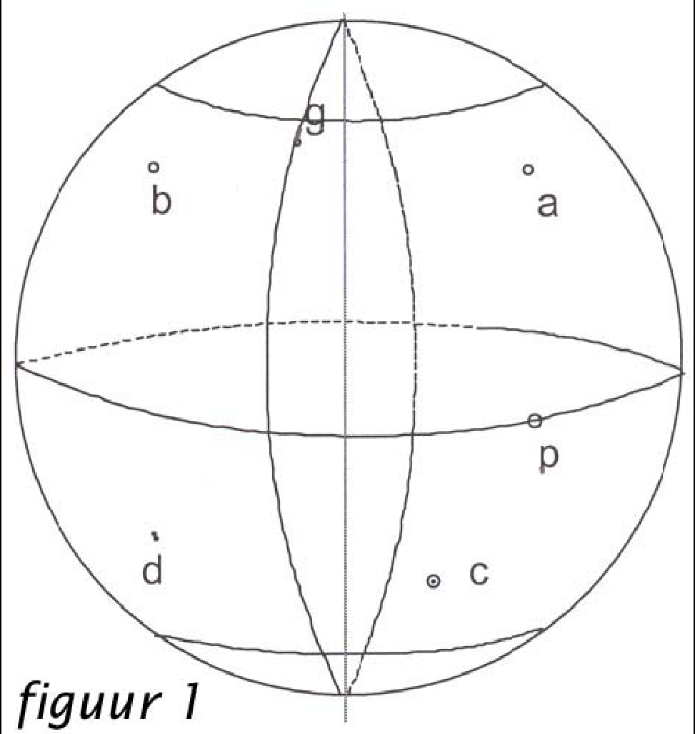
In this way one can give any place on earth an exact position. In this example, the location of the Westerkerk in Amsterdam is described as follows:

0 52°22,50’ N
004°53,03’ E

If we look at figure 1 we see:
A lies on North latitude and East longitude.
B lies on North latitude and West longitude.
C lies on South latitude and East longitude.
D lies on South latitude and West longitude.
G lies on North latitude and en 0° longitude.
P lies on 0° latitude and East longitude
THE SEA CHART

An actual spherical globe would be the truest representation of the Earth, but this would not be useful for navigation. In order to make a nautical mile equal 1 millimeter, a globe of 7 meters in diameter would be needed. Instead of a globe, charts are used that depict the earth (or parts thereof) as a flat surface. Working with these maps / sea charts is called “chart plotting”

In “chart plotting” we distinguish the following main operations:
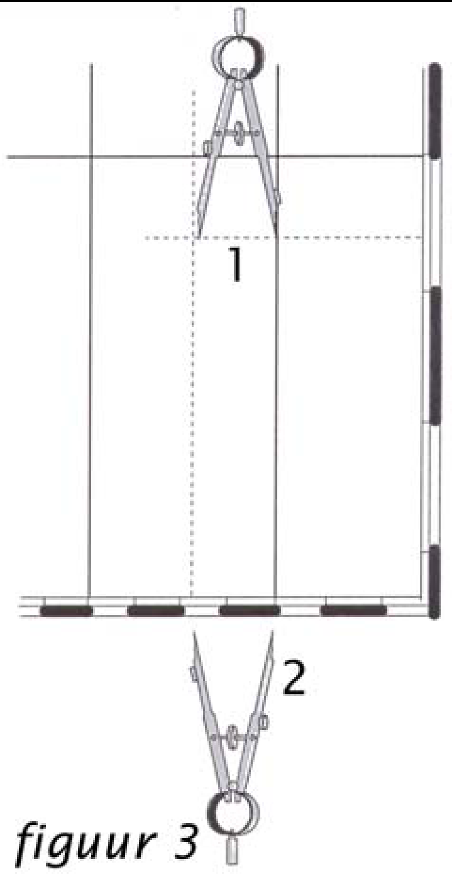
• Determining the latitude and longitude of a position on the chart
• Plotting a position on the chart of which latitude and longitude are given
• Determining a course between two positions
• Plotting a course or bearing line from a given position
• Measuring distances
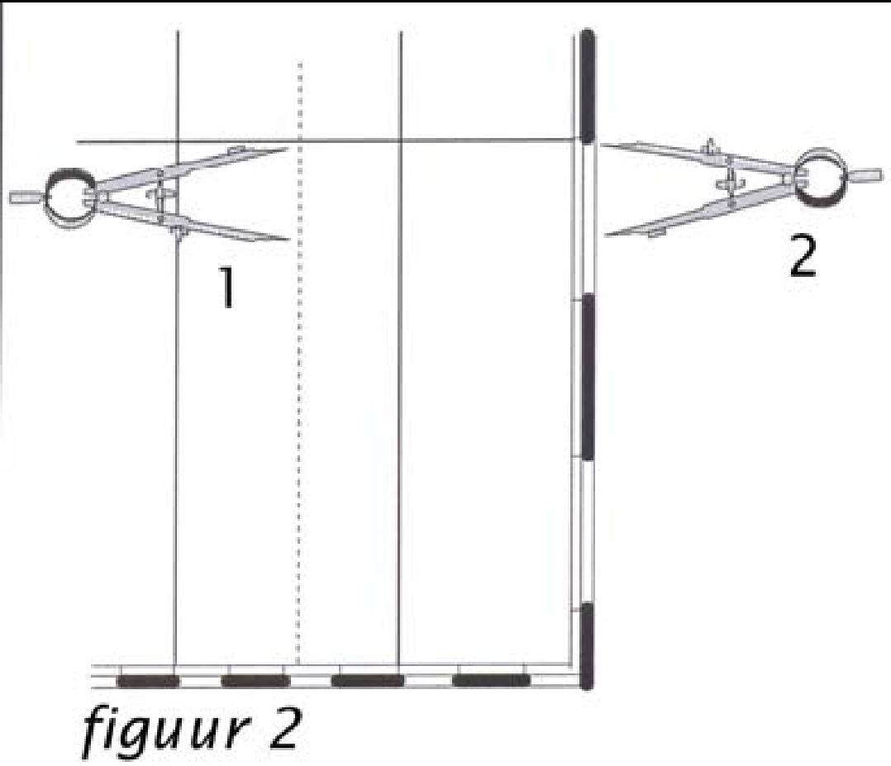
Determining latitude and longitude of a position on the chart
If we have to determine the latitude of a place on the chart, we place the drafting compass/caliper with one point on the position (please do not pierce the chart) and the other point on the nearest parallel (see Figure 2). Then we move the drafting compass to the vertical edge of the chart where we can read out the latitude.
For determining the longitude, we use the nearest meridian (see Figure 3), and we move the caliper to the horizontal edge of the chart and read out the longitude there.

Plotting a position on the chart of a given latitude and longitude
When we need to plot a position on the chart of which latitude and longitude are known, then we work in the exact opposite sequence to the method describe above. We start out by measuring the latitude at the vertical edge of the chart and we plot it from the parallel along a meridian (to keep it straight). We place a navigational triangle on the correct latitude and remove the compass for the moment. Now we measure out the longitude at the horizontal edge of the chart and place the compass along the triangle. With one leg on the meridian, the other leg of the compass now points to the geographical position.

Determining a course between two positions
To determine the course between two positions, we use a navigation triangle. The navigation triangle is placed along the course line between positions A and B (see Figure 4) with 0 (center of the triangle) on the meridian. The course from A to B can be read from the protractor on the triangle at the meridian. If no meridian is present, then place the triangle with the 0 on a parallel and read the course off the parallel. From a course read-off of a parallel, one needs to add or subtract 90° depending in which direction one has placed the navigation triangle.

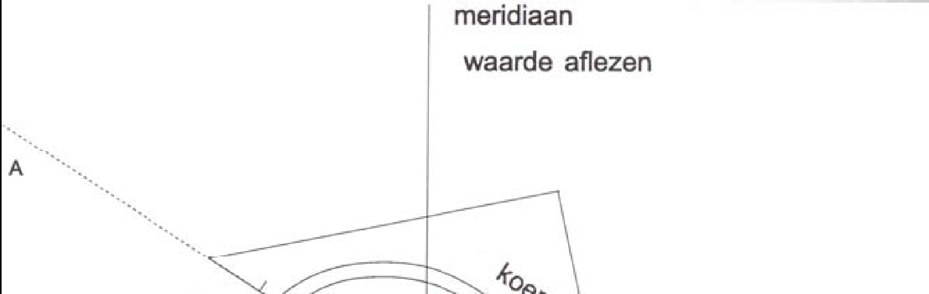
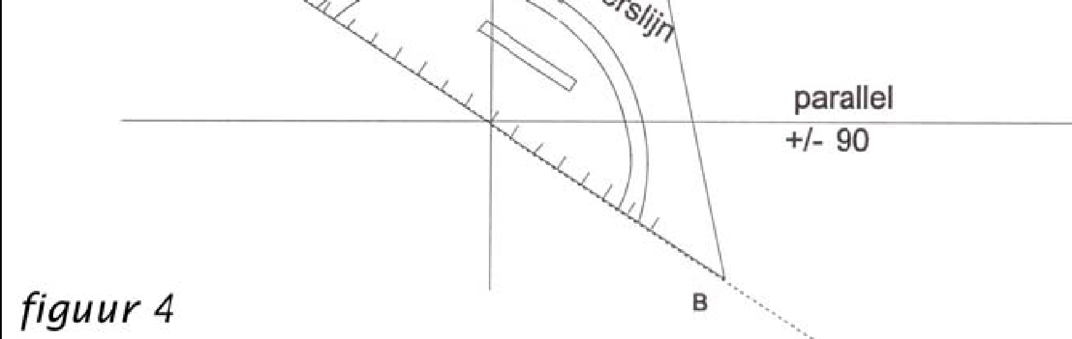

Plotting a course from a given position
In this case the navigation triangle is once again the appropriate tool. For plotting a particular course from a given position using the triangle, a parallel or a meridian is required. Placing the triangle with the 0 on the meridian or parallel, one turns the triangle so that the desired course can be read off of the meridian or parallel. Make sure that the position from which the course must be plotted is also along the long side of the triangle and draw the line. If the course has been plotted from a parallel, 90 ° must be added or subtracted, similarly to determining a course between two positions.

Measuring distances
When measuring distances, only the vertical edge of the chart can be used. The part that should be used is that which is located on corresponding latitude of the position. When measuring a distance, 1 minute on the vertical scale is 1 nautical mile (nm). The minutes are shown on the side of the maritime chart.

To measure the distance one takes the drafting compass and one takes the desired distance (or a part thereof, 10 x 1 nm is also 10 nm) between the compass points and measures the distance along the line. Or, one takes the total length of the line between the compass points and places the compass along the vertical edge of the chart to measure the distance.

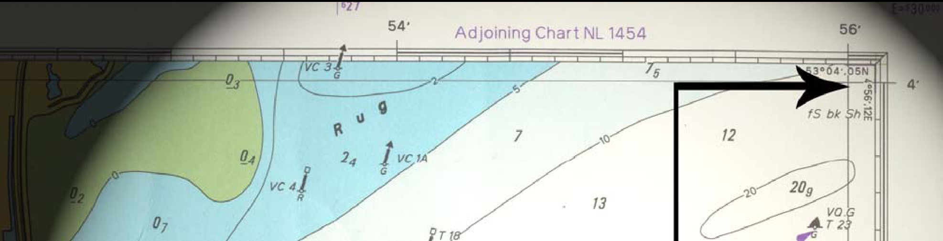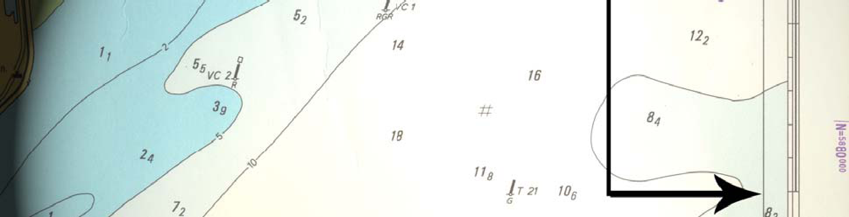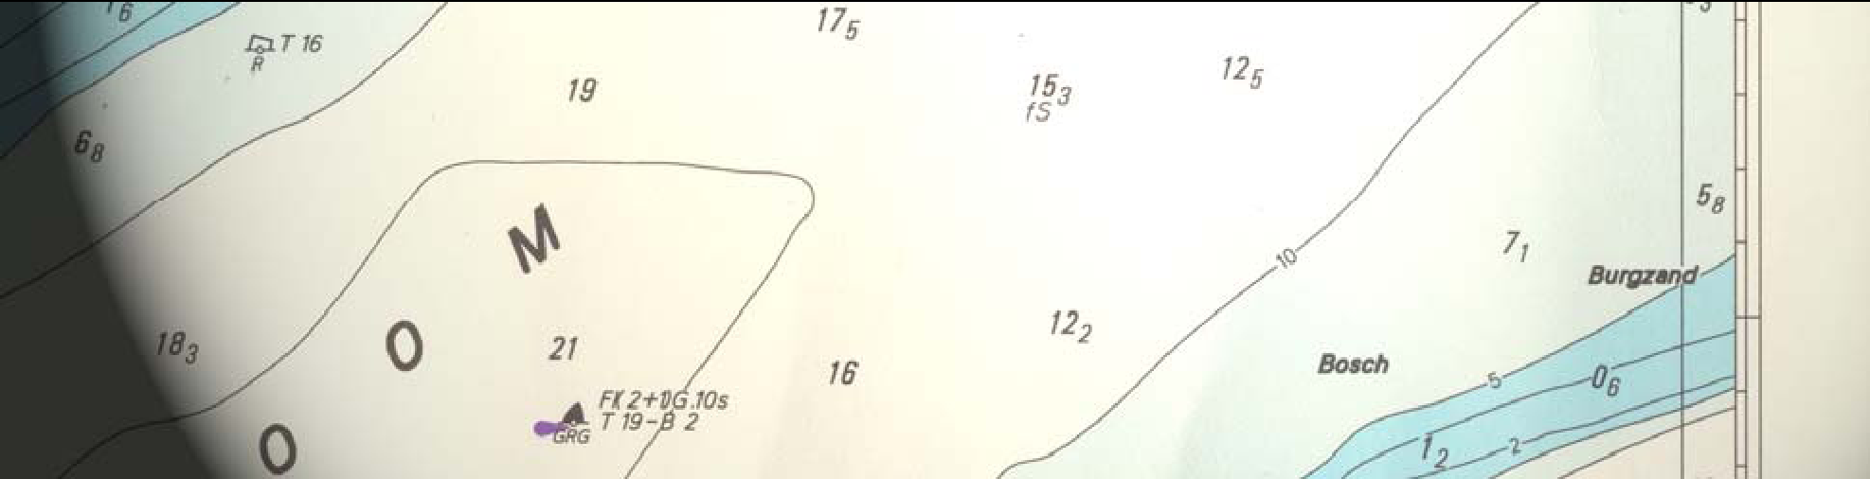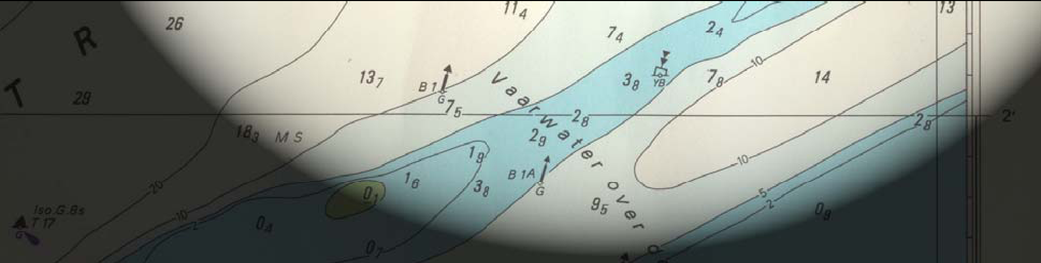
1 nm
figuur 5
DRIFT, CURRENT AND COURSE CALCULATION

To navigate correctly it is important to know which factors have an influence on the ship. This is because the compass heading and log speed may differ from the actual course and speed caused by these factors. This chapter will discuss the influence of wind and tide.

Drift
Drift is caused by the pressure of the wind on the part of the ship that is above the water. Drift gives the ship a certain movement through the water. The combination of magnetic heading, speed and drift gives us the course and speed through the water. If the ships drift is unknown, one can estimate the influence of drift by observing the angle between the wake of the ship and the heading.

Current
Drift aside, a vessel is also under influence from tide, also referred to as currents. The speed and direction of the flow of water is called tide. Tide is described as a vector and thus consists of two parts: power (in knots) and a direction. Other than a Northerly wind, a tide with direction North does indeed travel in the Northern direction. The direction of a Northerly wind and a Northerly tide can be remembered as follows:

Wind comes from… current goes to…

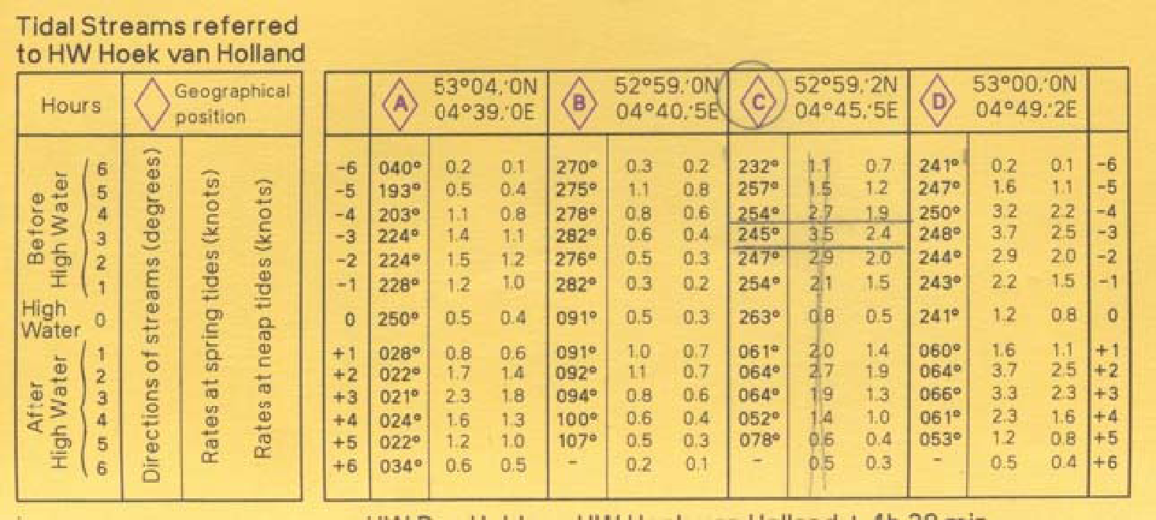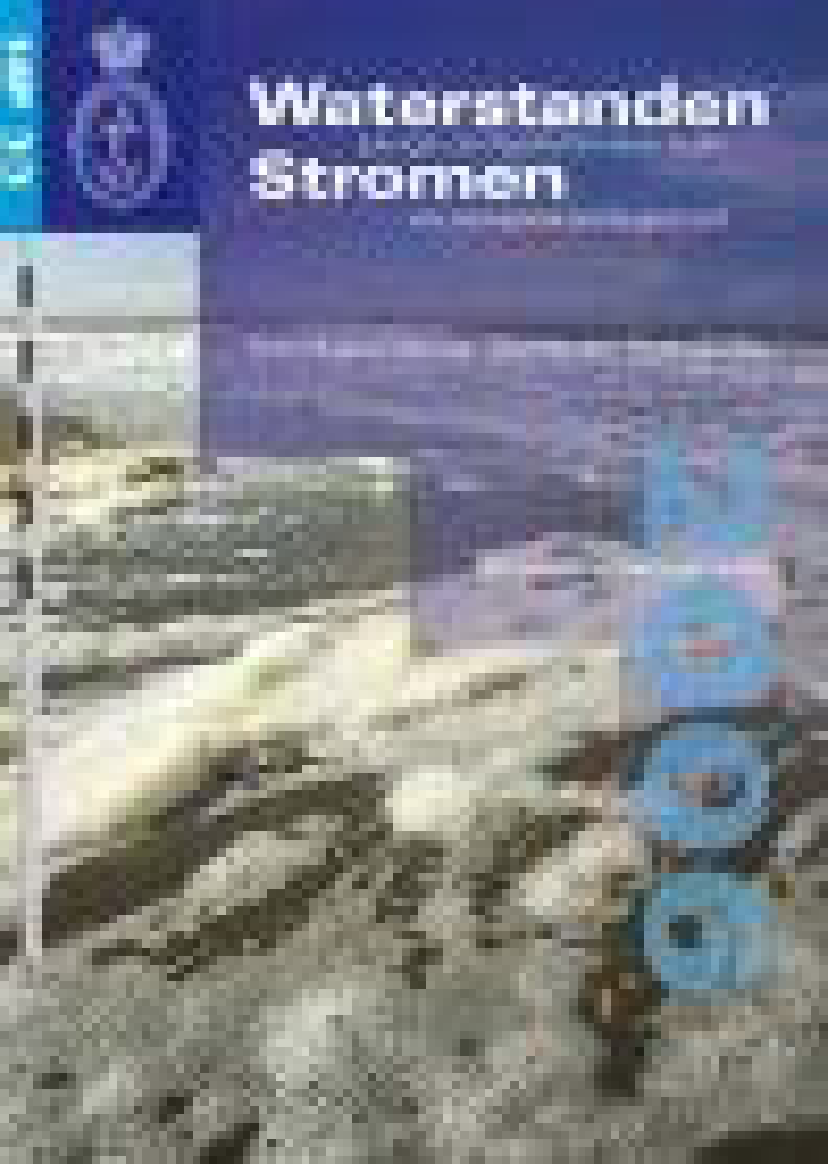
Figuur 6 Figuur 7

To look up the tide on a chart, proceed as follows: on the chart there is a table with various generic tide directions and strengths (see Figure 6). The title of the table shows us that all depicted tidal streams and times are relative to high water (HW) Hoek van Holland. As high water Hoek van Holland is under influence of the moon (amongst others) and thus constantly changing, we need to look up the times for high water Hoek van Holland for our specific day. In order to do this, we need the HP 33 (see Figure 7) publication. This annual publication gives a summary of all the dates and times of high and low water per location (see Figure 8).

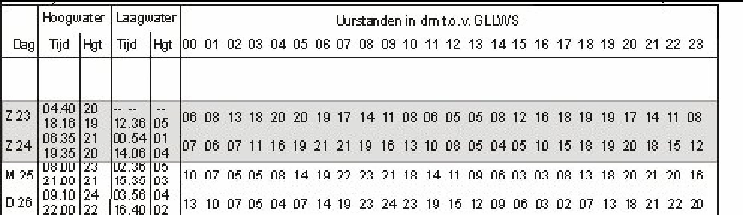
Figuur 8

In figure 8 we can see that on Sunday 23rd, high water will be at 04:40 and 18:16, and low water will be at 12:36.

Next to determining the tidal times, one also needs to determine whether it will be spring or neap tide. During spring tide, high water will be higher and low water will be lower than during neap tide. There will also be a stronger flow of currents. Springs in the North Sea is two days after the full and new moon. Full and new moon are shown in the HP33 as a filled or empty circle at a date (not shown in Figure 8). When it is two days after the crescent it will be neap tide. If a date is not exactly at spring or neap the values of the tide will have to be determined by interpolation.

With the time of HW and given spring or neap tide, one returns to the table on the chart (Figure 6). There are several columns with tide's data. At the top of each column you will find a purple capitalised letter inside a rhombus (in Dutch: a "stroomwybertje”), which corresponds to a position on the chart. Find the position that is closest to your vessel's position (Figure 9) and use the given tide data. Now use the correct column to determine the correct time, ranging from 6 hours before HW (-6) to 6 hours after HW (+6) and look at the data for either spring (left row) or the data for neap tide (right row) to find out how strong the tide is. Use the explanation in the column to the left of the table as a reminder (Figure 6).
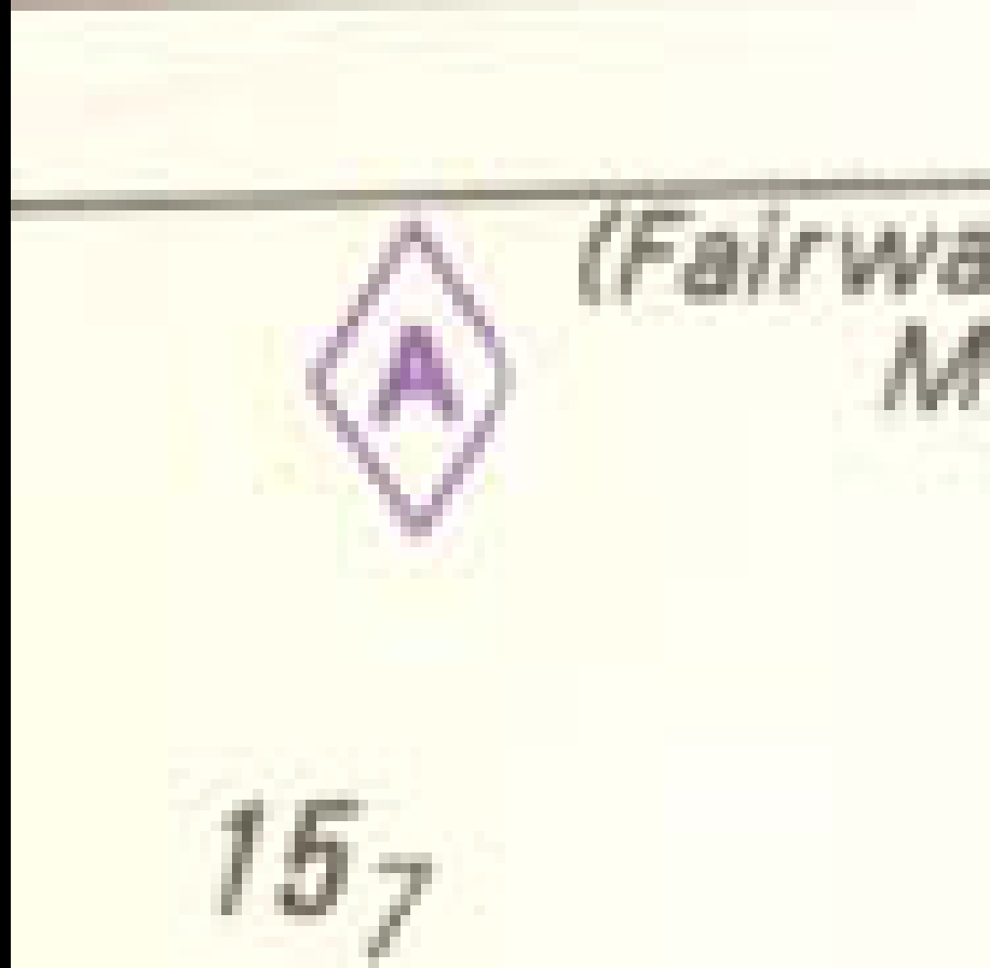

Figure 9

Course
Now we know the influence of drift and the strength and direction (vector) of the current, we can convert the compass heading (K_{k}) and log speed (speed displayed on the log of the ship, speed through the water {V_{w}}) to the course and speed over ground (COG and SOG). It is important to know what these values are, because if one wants to estimate one's position after a period of time, one must make calculations using these numbers.
The difference between the compass heading and the ship's course corrected for drift, is easy to calculate. One just has to add or subtract an angle. By doing this one determines the course through the water (K_{w}). One can therefore say that the course through the water is the compass heading plus or minus the drift angle.
(K_{w} = K_{k} ± drift)

Calculating the influence of tide is slightly more difficult. To do this one needs to take the strength and direction (vector) of the tide into account, as well as the speed and direction of the ship. For this reason, the effect of current is often determined graphically.
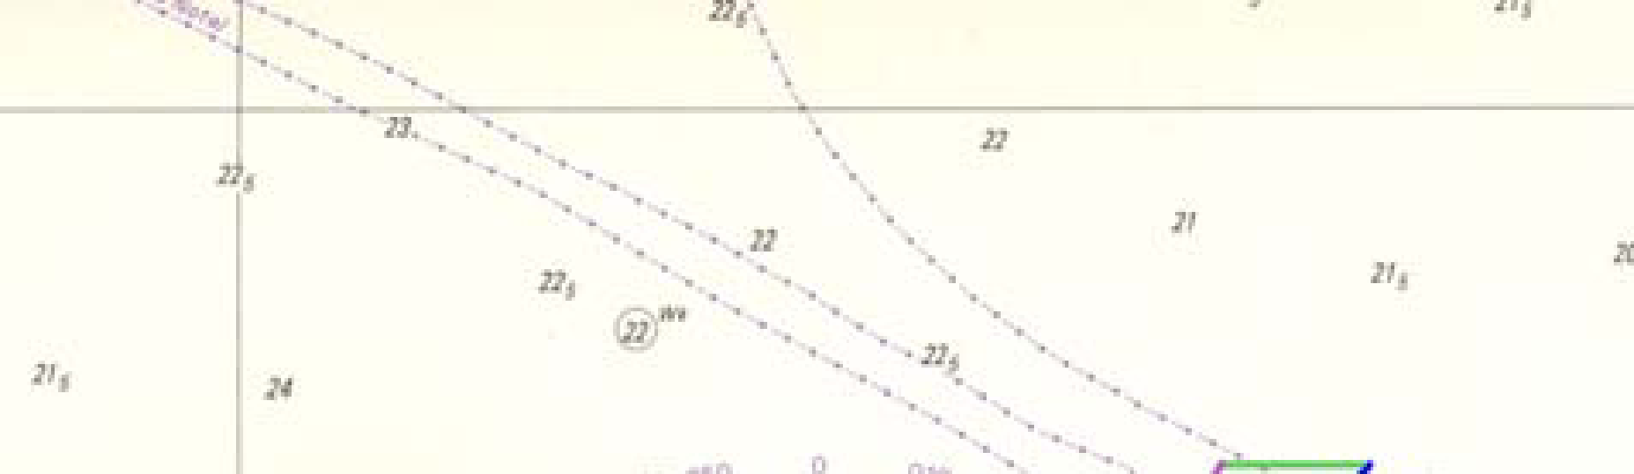
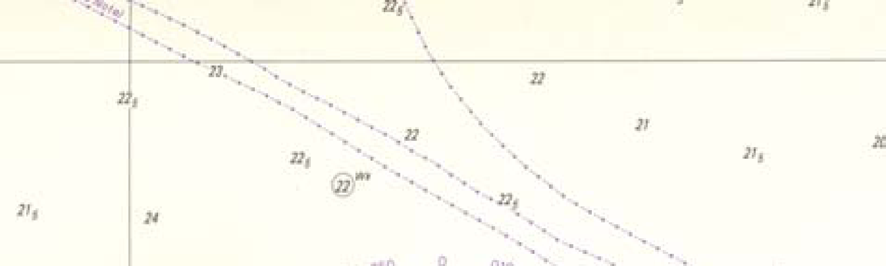

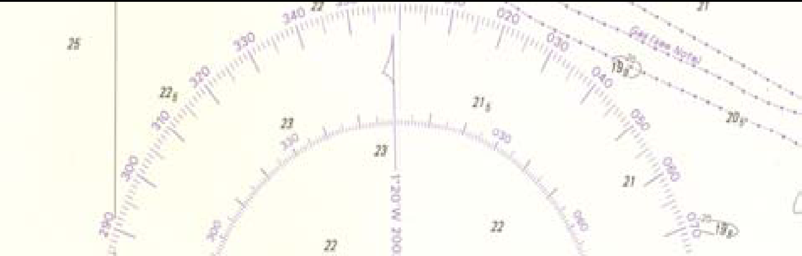
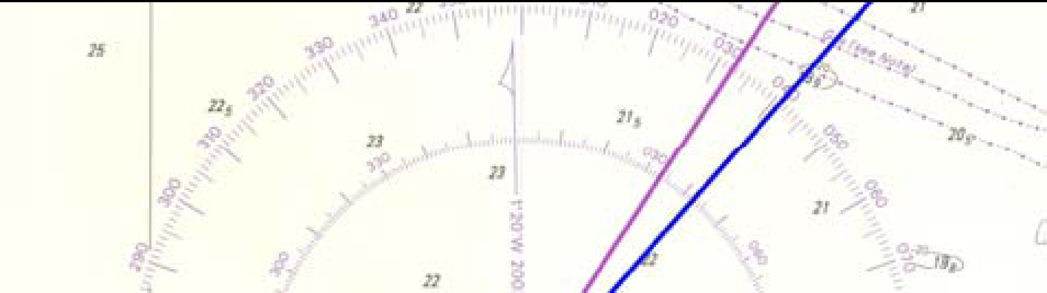

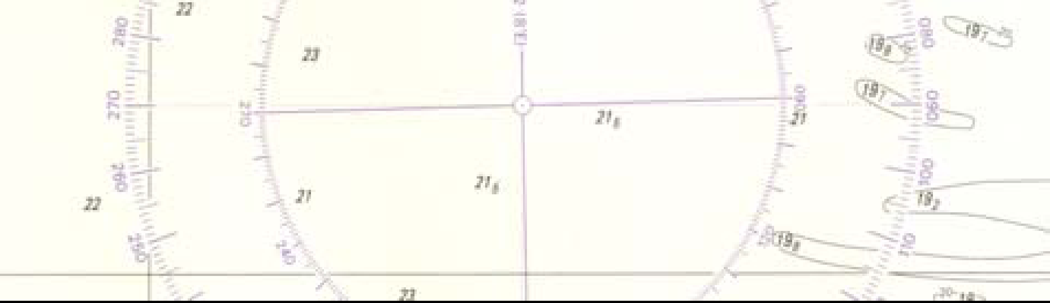
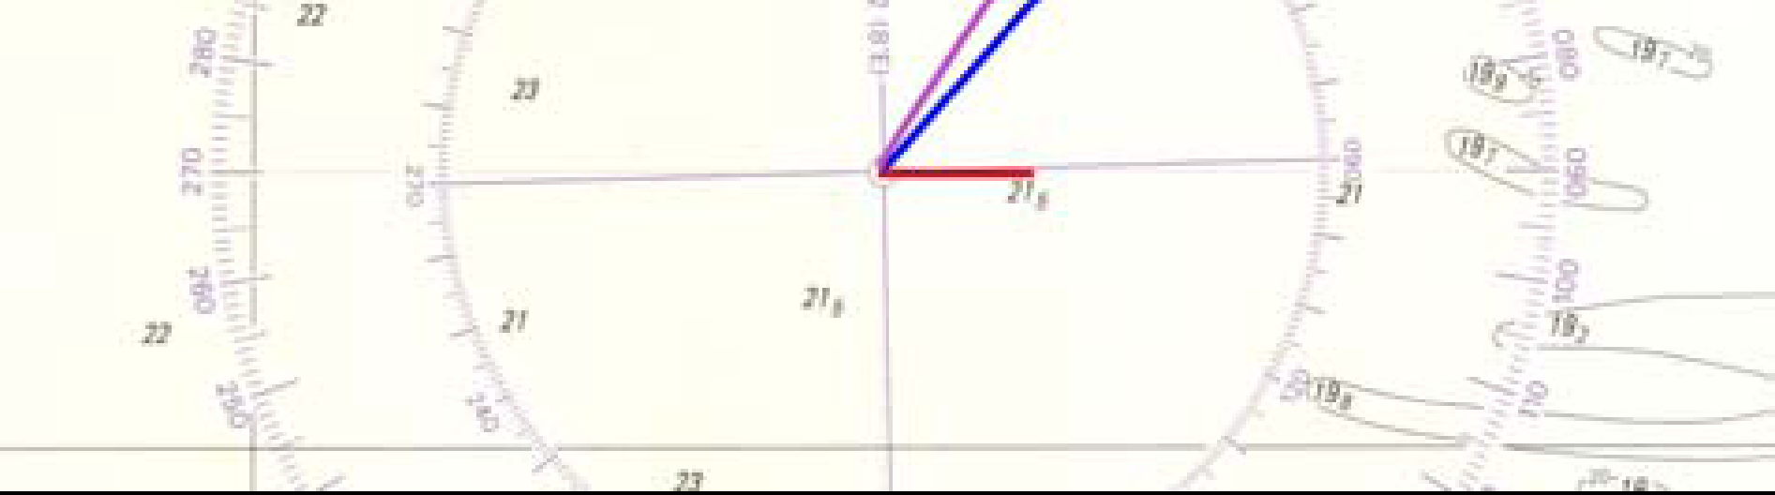

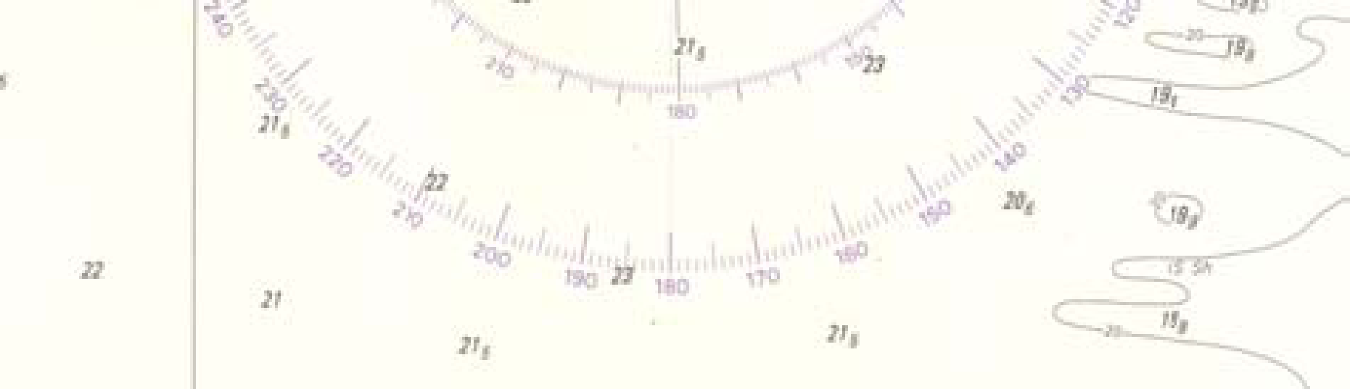
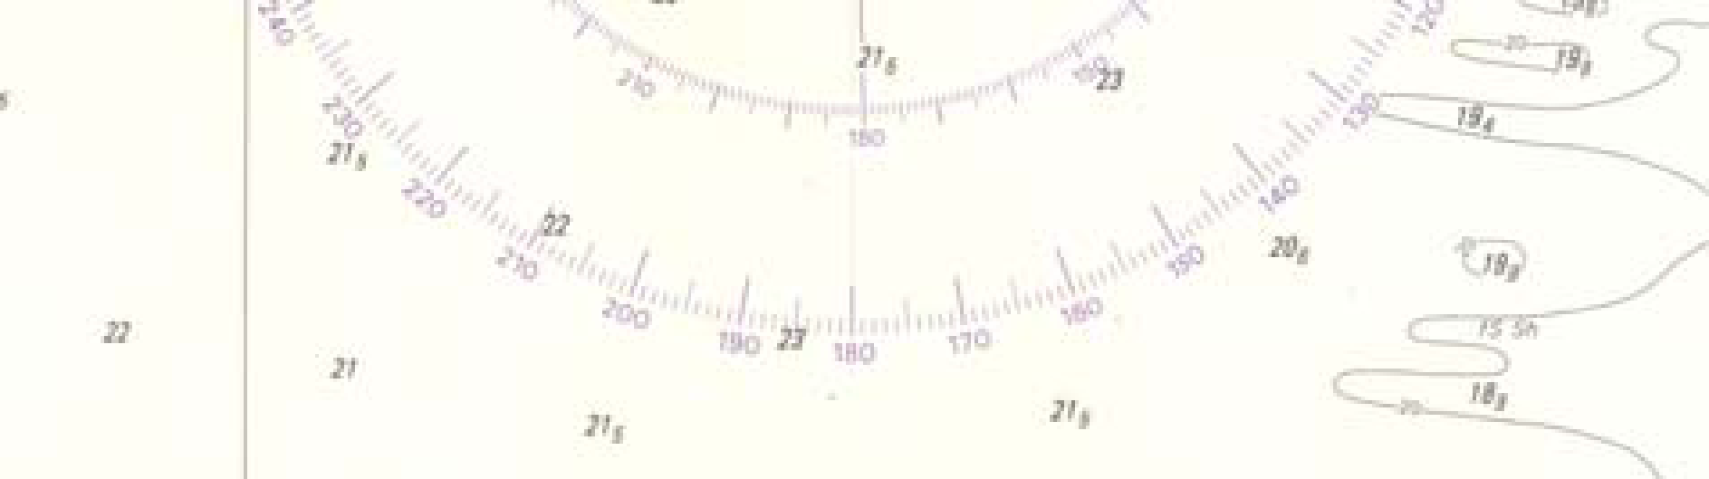

Figuur 10 Figuur 11

Graphically determining the effect of tide is done using the compass rose that is printed on the chart (Figure 10). Use a pencil to set out several lines inside this rose. One starts with one’s own course through the water (purple) and another for the tide (red). The length of the lines are determined by the speed of the ship and the strength of the tide. Make sure that only one scale is used (for example, this depends on the scale of your chart (!): two knots = 1 cm). Figure 11 shows an example of a ship with the compass heading 032 and a speed of 12.2 knots through the water. The current is 090 with 2.3 knots.

Now copy the value of the tide (red line) at the end of your ship's course and speed (the purple line), by drawing the green line. Then connect the end of the green line with the centre of the compass rose by drawing a blue line. In the example above, the course over ground is 041, and the speed over ground is 13.6 knots.

LOG ENTRY / FILLING OUT THE LOG

During the race, the log is the main way for teams to document their actions and thus gives themselves and the race officials insight into their actions.

All teams are expected to fill out a complete line in the log every hour. In addition, all teams are expected to enter every "event" into the log, thereby noting date, time and the new nautical details.

With “event” we mean - besides start, finish and intermediate finish - also changes of course, tacks, gybes, use of the engines, setting and lowering the sails, any conflicts with an opponent, sudden weather changes, etc.

The log must be submitted to the Race Officials on the ship of the Organizing committee within one hour upon arriving in port. Late or non-submission of a log may lead to a time penalty or even disqualification from the race.

Example LOG (to be filled out in Dutch):
Tijd | latitude  (N) | Longitude  (E) | Grondkoers  (GK) | Kompaskoers  (KK) | Snelheid | Logstand | DTF | Windkracht | Windrichting | Bijzonderheden
16.00 | 51°10” 068 N | 002° 12” 871 E | 069 | 040 | 7.8 | 1 | 8.8nm | 16 kts | NNW | Start
17.00 | 52°11” 361 N | 002° 19” 426 E | 069 | 031 | 1.1 | 5.8 | 3nm | 7 kts | ZW
18.00 | 52°22” 418 N | 002° 26” 941 E | 107 | 115 | 4.3 | 8.8 | 0nm | 11 kts | ZW | Tussentijdse finish

Term | Meaning
Tijd | Netherlands time (Central European Time; during event GMT+2)
Bijzonderheden | Event, for example strong tide, passing finish, use of the engine, etc.
Latitude (N) | Latitudinal position
Longitude (E) | Longitudinal position
GK | COG, Course Over Ground
KK | Compass Course
Snelheid | True speed (speed over ground, SOG) in knots (consult GPS)
Logstand | Distance passed through the water
DTF | Distance to finish
Windkracht | Windspeed in knots
Windrichting | In compass direction: Southwest = ZW or South South West = ZZW

UNITS, TERMS AND ABBREVIATIONS
° Degree
’ Minute (position)
” Second (position)
1 nautical mile (nm) 1852m
Knot nm per hour
Latitude Distance North or South of the equator
Neap tide Period of time in which the tidal ranges are at their minimum
COG Course over ground
HP33 Hydrographic Publication nr. 33: water heights and tides
HW High water
Kk (Cc) Compass course
Tropic of Cancer 23,5°N
Longitude Distance east or west of the prime meridian
Log Travelled distance
Log speed Speed through the water
LW Low water
Meridian Line on the globe running from pole to pole
nm Nautical miles (not the same as statute or land miles)
North 000°/360°
North Arctic Circle 66,5°N
Prime meridian Meridian through Greenwich, 0°
East 090°
Parallel Line on the globe parallel to the equator
SOG Speed over ground
Spring tide Period of time in which the tidal ranges are at its maximum
Tropic of Capricorn 23,5° S
“Stroomwybertje” Symbol on the chart correlating with a referenced position on the current table.
V_{gr} Vaart over de grond, (Speed over ground, true speed)
West 270°
South 180°
Southern Arctic Circle 66,5° S

