Safetyreader

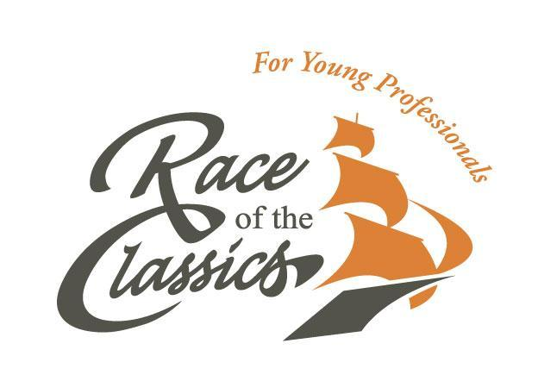

14th edition
October 8 – 13, 2019

Table of contents

- Introduction p. 3
- Safety onboard and in the harbour p. 4
- Safety at night p. 5
- Safety at sea p. 6
- Emergency flowchart p. 7

Introduction

Sailing inherently includes situations that may be dangerous. This is the case not only at sea, but also in ports. Safety onboard is of key importance to the organizing committee of the ROTCYP and we will do everything in our power to ensure your safety. Nevertheless, all participants have the responsibility to look after themselves. Safety is best ensured when dangerous situations are prevented. This reader will address safety advice and precautions which must be taken to prevent unsafe situations.

The Race Officials (Wedstrijdleiding in Dutch) will make sure the teams respect the guidelines and rules as lined out in this safety reader. Should you have any concerns or questions, do not hesitate to contact us by telephone, email or during the race by VHF.

Make sure that you discuss specific safety issues for your ship with the skipper before setting sail. Every vessel is different and requires different precautions. In case the skipper does not provide safety instructions, please ask him/her on your own initiative.

On behalf of the entire organization of the Race of the Classics for Young Professionals, we wish you, your team and the ship a fantastic and safe week!

Yours sincerely,

The Race Officials ROTC YP 2019

Willem Steketee (06 28 48 98 60)
Jochem de Jong (06 49 04 29 95)
Christof Westland (06 24 49 39 13)
Pim van Dijk (06 20 45 86 91)

E: wl@rotcyp.nl
During the ROTC the Race Officials can be reached at 06 28 48 98 60 or by VHF.

Safety onboard and in the harbour

Safe gangways
Even after mooring, a vessel still moves slightly. This may cause dangerous situations when people want to board or disembark the vessel. Make sure a gangway is tightly secured with additional lines/handrail to hold on to. Furthermore we advise you to tie a net underneath the gangway in order to prevent falling into the water in case someone slips. Only use the secured gangway and never try to jump onto a ship! Discuss the gangway safety with your skipper. The race officials will check the safety of the gangways after mooring.
No loose/moving object on deck
Always make sure your vessel is tidy, both at sea and in the harbour. We advise you to tidy up all loose, moving objects (such as, but not limited to lines, buoys, sailing gear) directly after mooring in the harbour with your team. Loose objects lying around are a tripping/falling hazard. Furthermore, never go barefoot when onboard a ship: always wear boots or shoes that provide adequate grip.

Lifebuoys, lifejackets and lifelines must be onboard every sailing vessel. Check if they are still in the right place after a trip. Always be sure to know where the lifebuoys, lifejackets and lifelines are on the vessel. On a sailing vessel the risk of a person falling into the water cannot be ruled out. Instant action is required in such a situation. It is therefore essential that you know where to find the safety gear. Never use safety gear for anything other than its intended use. Be sure to have a ladder ready in case someone falls in the water. Discuss these issues with your skipper.
Lifebuoys, life-jackets and lifelines
Swimming is prohibited at all times
Swimming is strictly prohibited at all times, at sea and in the harbor. Swimming can cause very dangerous situations as swimmers are easily overlooked by in- and outgoing traffic.
Jib-net
The jib-net is always a nice place to relax. It is usually comfortable and safe to do so under mild weather conditions, but make sure you always wear a lifeline as you may fall climbing into or out of the jib-net.
On deck
Be sure to never be alone on deck: always move around with your buddy and let someone know where you are.
Mast and shrouds
Never climb into the mast without permission of your skipper. This is dangerous as you may fall down. If you want to climb the mast or shrouds, always ask your skipper and always wear climbing- and safety gear.
Slippery quays and jetties
Quays and jetties have a tendency to be wet and slippery. Be sure to wear appropriate shoes with enough grip and do not walk too close to the water.

It is prohibited to drink alcohol at sea. After mooring and ensuring safe gangways, you may consume alcoholic beverages. Even when drinking alcohol, always take responsibility for your own and other people’s safety!
Alcohol

Safety at night

“Getting home”
After the parties the teams will return to their own vessel. Prior to and during the party people will have consumed alcohol. Therefore additional caution is needed while moving to and around the ship at this time.
Per team 2 people sober
We require 2 people per team to be sober to take care of the safety of their team members in case something happens. We also ask them to keep an eye on what’s happening on the quays, onboard and to intervene in case of unsafe situations. We advise the people who are sober to be onboard when their team members return to the ship and to assist with embarking until everyone is onboard.
Do not cause nuisance
The organization would like to stress that it is not allowed to play loud music, drink alcohol or to cause any other form of nuisance on deck and in the harbour during and/or after the parties. Please be mindful of your fellow yachtsmen and people living in or around the harbour.
Do not trespass
It is forbidden to trespass onto other vessels that are not involved in the Race of the Classics, unless doing so is unavoidable in order to get to shore from your own vessel. These vessels do not belong to the group, and more importantly, dangerous situations may occur as you don’t know the situation on board.
Follow directions of the organization
All participants must follow all directions given by the organization of the Race of the Classics. The organization reserves the right to come aboard each of the participating vessels to observe and verify that the safety guidelines are followed.

Safety at sea

At sea, the skipper is responsible at all times. Together, the team, the skipper and the crew need to create and maintain a safe environment at sea. Please find some tips below that will increase safety and reduce the likelihood of an accident.
Warm clothing
Be sure to keep warm! The human body cools down quickly at sea and once cold it is especially difficult to warm up again. Hypothermia can be dangerous! Wear enough warm clothes and wear layers. Always try to keep your body and your clothes dry. We advise to wear proper waterproof sailing gear, including waterproof boots.
Eat and sleep well
Healthy, proper food and enough sleep are important at sea. Sailing takes a lot of energy, so you need to put ‘fuel’ into your body as well. Furthermore, by keeping a good nutritional state you reduce the likelihood of sea sickness.
Life-jacket
Every participant is obligated to be in possession of a workable life-jacket (minimum NEN approved, 275 Newton and including a SOLAS light). For your own safety we strongly recommend that you wear your life-jacket at sea. Ultimately, the skipper is responsible for the safety on board the ship. He or she can therefore decide that conditions require to deviate from our guidelines. ALWAYS wear your life-jacket on top of all your clothes, never underneath. When inside the ship, do not wear your life-jacket.
Tell your skipper where you are
Always make sure that the skipper and/or the crew knows where people are on the vessel. This is particularly important at night as it is more difficult to see where people are located on the vessel. Never move around the ship alone, not at night, but not in daytime either! Always be sure to have a buddy with you. The skipper will inform you about particular guidelines onboard the ship.
Sea sickness
Sea sickness occurs frequently and there is not much that can be done about it. It helps to have something in your stomach, so eat something light or some soup. There are pills, band aids and wristbands on the market to prevent nausea, however, none of these agents have been proven to be effective. Furthermore, side effects have also been documented. When you notice a funny feeling in your abdomen, nausea or when you start yawning, it might help to sit on deck with your head in the wind and look at the horizon. Check with your skipper first if the circumstances allow this. Depending on the conditions, you might be obligated to be hooked up, or you might even be restricted to staying below deck. Lying in your bed and going to sleep might then be your only possible remedy.

Should you need help or tips, please refer to the race officials.
Emergency flowchart

Should an emergency or accident occur despite all combined precautions, it is important to communicate about the emergency quickly and accurately. It is very important that the ROTCYP organization knows about all accidents or emergencies. Always inform us!

Please follow this flowchart in case of emergency / accidents.

Emergency?

Inform skipper

Inform organization ROTCYP
Within GSM reach:
06 28 48 98 60 (Willem)
06 49 04 29 95 (Jochem)
06 24 49 39 13 (Christof)
06 20 45 86 91 (Pim)
Out at sea:
VHF 16

Inform team

Important: Please do not post anything on social media such as Twitter/ Facebook/ LinkedIn to protect the privacy of the people involved.

